1/ Home
Partnering with you to build a more sustainable tomorrow.
Evergreen Wireless is committed to our environment, providing businesses with eco-positive, sustainable, products and services that positively contribute to Environmental, Social and Governance (ESG) corporate programs, a critical strategy with most organizations, enabling them to achieve their sustainability objectives.
As an industry-leading provider of Certified Pre-Owned (CPO) smartphones and complementary Buy Back programs for enterprise clients, Evergreen Wireless assists businesses in reducing e-waste, optimizing device lifecycles, and managing mobile device investments.
Our comprehensive portfolio of products and services delivers turnkey mobile device solutions that drive a measurable environmental benefit.
Buy Back
  - Receive a high value trade-in credit for used devices, regardless of their condition, maximizing the device investment and minimizing the environmental impact.
CPO Device Bundles
  - Our Grade A certified devices are in like-new condition, backed a 2-Year warranty and include a protective case, screen protector, charger and cable – packaged in a biodegradable box.
New Devices
  - Through strategic partnerships with select manufacturers, Evergreen Wireless offers exceptional value on mobile phones, tablets, mobile hotspots, wireless home phone, wireless broadband solutions, smart home IOT and streaming set-top boxes.
Custom Kitting
  - From tailored kitting to end-to-end MDM setup and oversight, Evergreen Wireless delivers turnkey staging and deployment solutions that streamline operations and accelerate readiness.
Connected Bundles
  - Two prepaid retail-ready bundles are available. Get a new 6.6” LTE smartphone with either a pre-activated 30-day plan, or a ready-to-activate plan of your choice.
Short-Term Device Leasing
  - A flexible solution for organizations with a dynamic workforce. Lease CPO devices for up to 6-month terms for as little a $50.00 per month. Simple, predictable and cost-effective.
Extended Warranty
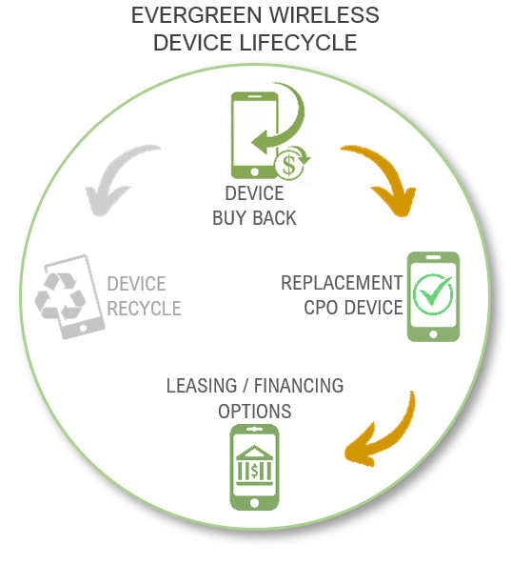
  - With Evergreen ExtendedCare+, your device warranty term extends to match your carrier plan—delivering uninterrupted coverage and peace of mind for the entire contract duration.

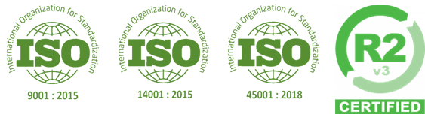
Evergreen Wireless is part of the Bridge Wireless family, a strategic partnership rooted in innovation and backed by industry certifications for reliability and trust.

2/ Trade In
The Evergreen Wireless Buy-Back program ensures that you maximize your mobile device investment while minimizing the effect on our environment.
Our simple 3-step process allows you to quickly get a credit for your previously used devices, regardless of their condition, and receive maximum trade-in market value for them.
STEP 1: Let us know what product you have by using the tool below, or for several devices send us an email with the details, and you will receive the buy-back quote.
STEP 2: Ship your devices to us.
Note: Account ID’s and Device Management Software (MDM) must be removed or disabled.
STEP 3: Get your trade-in device credit!
DOWNLOAD OUR DEVICE BUY-BACK PROGRAM OVERVIEW:

BUTTON FOR QUOTING TOOL

Rest assured, any data on your returned devices is safe with us. Using government-grade tools and processes, Evergreen Wireless adheres to the strictest industry standards for permanently removing data from previously used devices.
A detailed report, including all testing results and data erasure confirmation is issued for each individual device, including a final certificate of compliance.
DOWNLOAD OUR DEVICE DATA WIPE PROCESS OVERVIEW:
Reducing e-waste
When a device reaches the processing stage, our certified recycling protocols ensure it’s handled responsibly and in accordance with strict environmental standards. Our priority is to always bring a non-functioning device back to life by making reasonable repairs to it and returning it to an active device pool.
When a reasonable repair is not feasible, or the device is simply unrepairable, we remove all good functioning parts from it.
- We utilize the functioning good parts to repair other devices, thus keeping authentic OEM parts in the device and avoiding the need to buy additional replacement parts.
- Broken or non-functioning parts are reassembled to make a complete broken parts device. These are then consolidated and either sold to electronic buyers or recycled.
Processing e-waste
Batteries
Swollen or unusable batteries that were removed from a device are susceptible to combustion and/or leaking. The following precautions are taken to minimize any danger or toxins when they are processed.
- The electrical contacts of the battery are covered to ensure they do not short-circuit the battery if they come in contact with another object.
- The batteries are stored in a fire-resistant bag in a cool place.
Our batteries are only processed by a government certified e-waste company for proper disposal.
Broken electronic parts and / or devices
Devices that are non-functioning and are comprised of broken parts, are offered to companies that acquire such products for alternative uses.
Devices that are not fit to be sold as above or for parts, are only processed by a government certified e-waste company for proper disposal and/or recycling.
DOWNLOAD OUR DEVICE RECYCLING PROCESS OVERVIEW:

3/ CPO Devices
Evergreen Wireless redefines value in the Certified Pre-Owned (CPO) industry—delivering top-tier devices at competitive prices, all backed by a standard two-year warranty for peace of mind.
But that’s just the beginning.
Every Evergreen Wireless CPO device comes bundled with premium accessories at no extra cost, making it a complete out-of-the-box solution:
- Grade A Certified Pre-Owned device
- Two-year device warranty
- Protective case
- Screen protector
- Charging cable
- Wall charger
Experience quality, reliability, and unbeatable value—only with Evergreen Wireless.

Advance Exchange Warranty Support
In the very unlikely event that your Evergreen Wireless CPO device does require repair during the warranty period, we will send you a replacement device of the same or better model. You will then have 30 days to move your data over to the new device and ensure it is setup to your liking, before sending back the defective device. Simple and worry-free.
DOWNLOAD OUR ADVANCE EXCHANGE PROCESS DOCUMENT:

Device Refurbishment Process
Evergreen Wireless utilizes certified Device Repair Technicians to replace defective parts and worn components, restoring devices back to working condition and improving their grade value.
This refurbishment process involves several steps to restore used or damaged devices back to like-new condition:
- Inspection and testing
- Data wiping
- Repair
- Restore
- Retesting
- Gading and cleaning
DOWNLOAD OUR DEVICE REFURBISHMENT PROCESS DOCUMENT:
Evergreen Wireless uses industry standard grading for all CPO Devices. This ensures compliance and transparency across all devices, for a consistent and predictable user experience.
The same grading is used on all devices, all the time. The latest grading tools provide for a scientific grading rather than a subjective opinion - and our functional condition grading is guaranteed!
DOWNLOAD OUT CPO GRADING STANDARDS:

4/ New Devices
Evergreen Wireless partners with select Original Device Manufacturers (ODM) partners to bring Canadians premium quality entry and mid-range level devices.
Our portfolio of new devices includes Phones, Tablets, Wireless Broadband, IoT, Wearables, and Trackers.
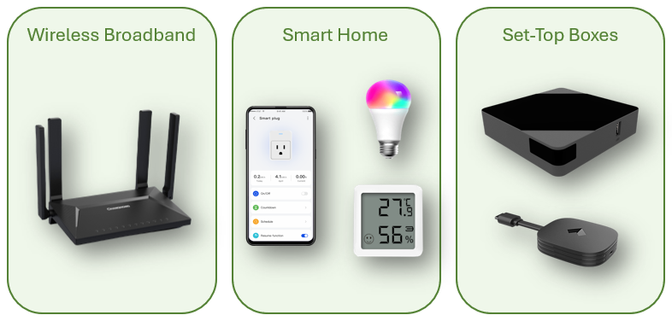
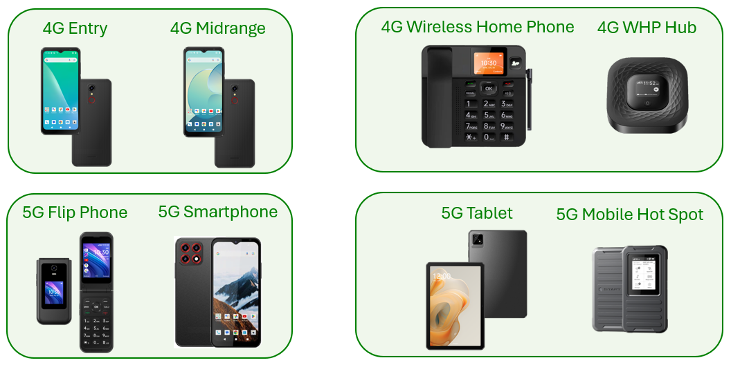
In addition to wholesale devices, Evergreen Wireless also provides retail-ready solutions. Our Connected Prepaid Bundles offer simplicity and value:
INSTANT-CONNECT Prepaid Bundle: LTE SKY Smartphone with a pre-activated Koodo SIM Card – Instantly ready to go with a full prepaid plan for 30 days.
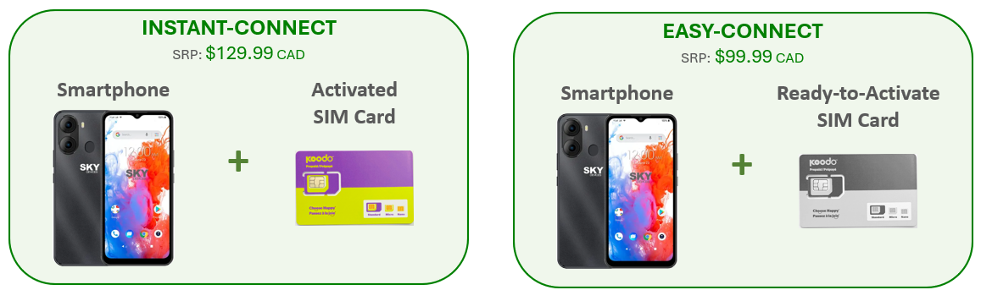
EASY-CONNECT Prepaid Bundle: LTE SKY Smartphone with a Koodo Prepaid SIM Card – Everything you need to get connected.

These Evergreen Wireless Prepaid Bundles can be purchased at your favourite retailer, or directly from our website using the buttons below:
BUTTONS TO BUY ONLINE (future?)

5/ Leasing
Short-Term Device Leasing
In today's dynamic workforce environment, businesses are increasingly seeking flexible solutions to provide the latest smartphones to non-permanent employees, without the burden of full device ownership costs.
The Short-Term Device Leasing Program from Evergreen Wireless offers an innovative alternative, allowing businesses to lease CPO Device Bundles for a fixed term providing the ultimate financial flexibility.
With fixed costs from $50.00 per month, and leasing terms from 6-months, this solution provides the advantage of having the latest technology with a predictable monthly expense, while eliminating upfront costs.
DOWNLOAD OUR DEVICE LEASING PROGRAM OVERVIEW:

Evergreen Wireless has partnered with one of North America’s largest independent technology and equipment financing companies, to bring Canadian companies financial flexibility and options for purchasing mobile device products and solutions.
Our sales team will be able to provide you with an overview of options that minimize risk and maximize your investment.

6/ Contact Us
Contact Us form (currently on the site)

For warranty support, please include details including the original purchase date, copy of your purchase invoice, and the device IMEI (serial number) for faster service.

